**Assignment 12**

Name: Yash Shinde  
NUID: 400067  
Course: DWBI (Online)

Source flat file:

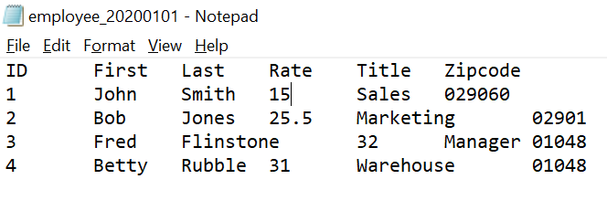**Selecting Dimension Table and Keys for SCD**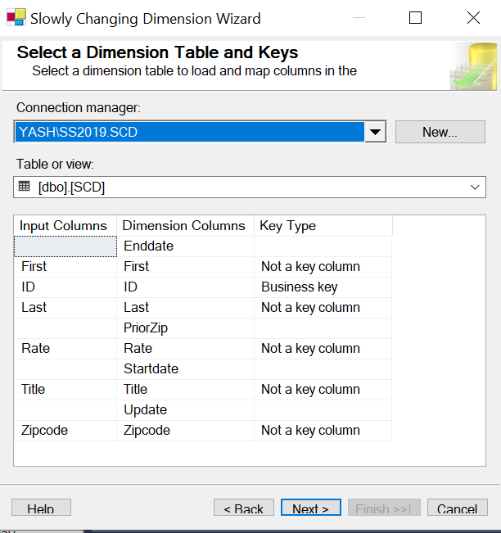

**Package dtsx design**

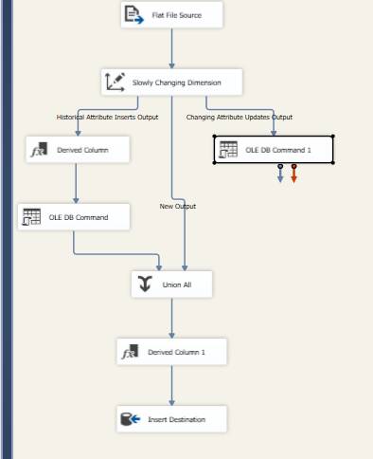

**1: Initial Load**:  
  
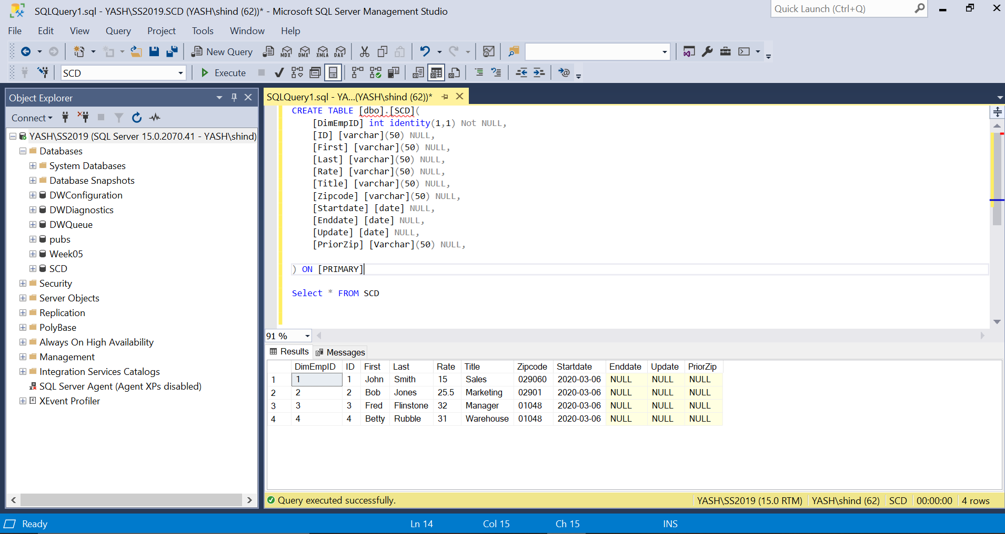

**2: Change in Zipcode of betty, Name of John, and Raise for Bob**

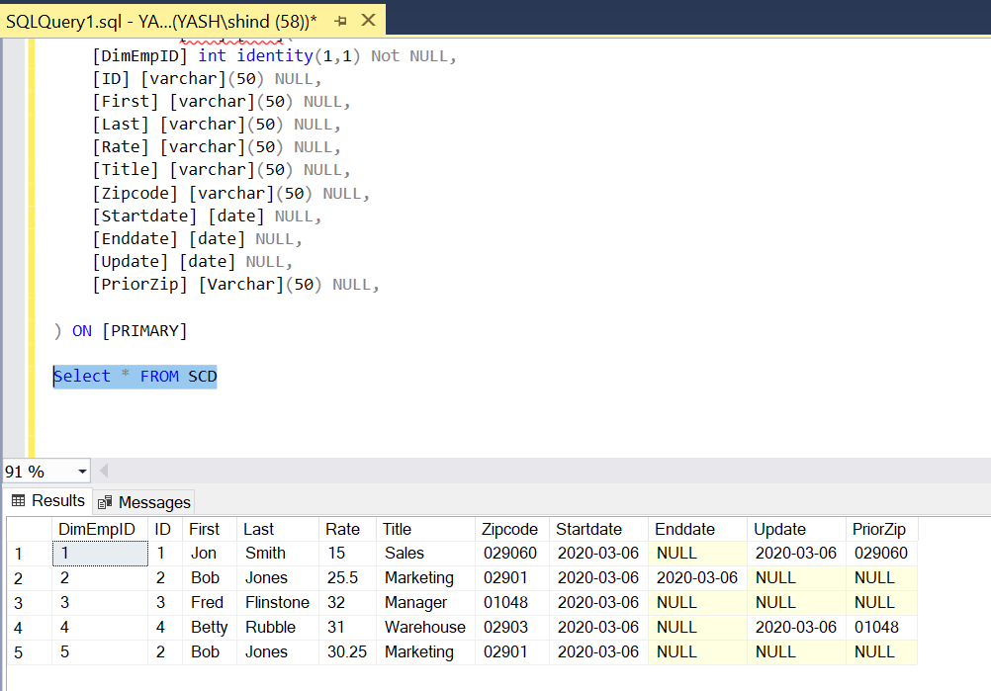

**3. New Entry**

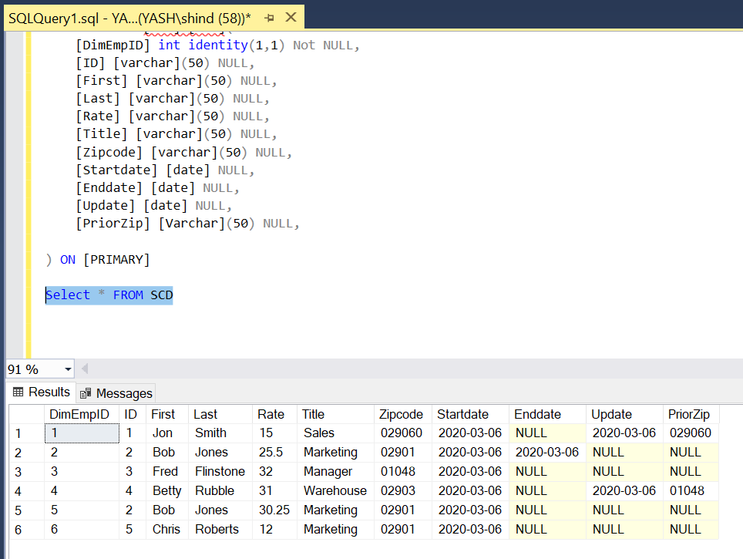

**4. Bob Jones changes name to Robert Jones**

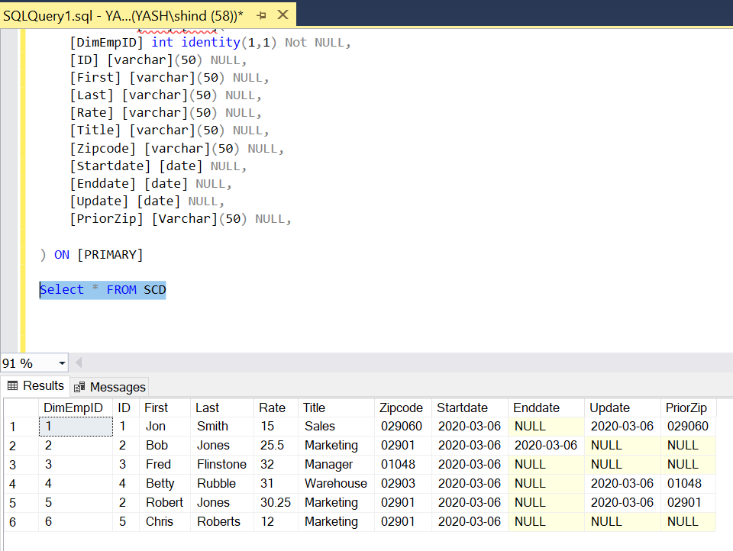

**5. Delete Row**